COGSCI120
Human Computer Interaction

Project III
Context Enriched Digital Photography

Martin Tall, Josh Kirsch and Bryan Waldberg.

University of California, San Diego 03/15/2007
Intro
The motivation for this project came when took a look at our lives and the lives of others around us. We found that many people document their lives with digital photographs. Whether they post pictures on My Space and Facebook or simply store albums on their own personal computer, digital photos are an integral part of the future. People are so attached to photos because it is a way to remember events in their lives and who they shared these events with. Seeing a picture could be a hook to memories and these memories are what define a person’s life. This idea of sharing past events and stories is a large part of our social ecology and is part of what makes us human. One of the major problems with this is that most people spend massive amounts of time on organizing their photos or uploading them to servers such as Facebook. Another issue with digital photography in that they it does not store contextual meta-data within the file. The digital images do not store information about who’s in the picture and where/when it was taken. This kind of information will currently require a large amount of time and work put in by the user. We spent a fair amount of time to discuss methods on how to store photos in a friction free manner that not only preserves context (physically and socially) but makes this process automatic and easy for the user. What if there was a way to automatically store one’s pictures online and automatically tag them with a location, people in the picture and a time stamp. This would provide an opportunity to automatically organize the information and build a rich, easily accessible interface to this data. These ideas are what helped us come up with our project. We call it Context Enriched Digital Photography (CEDP). This consists of a digital camera equipped with a GPS and Bluetooth and a software package which organizes these meta-data enriched photos in an easily assessable manner.

Technology
First let us start off with the technology that we think needs to be available. The "camera" that we envision has similar functionality to the Apple iPhone or similar smartphone. Our idea for the "camera" needs to have a few key features that will enable the interactions we want.
Necessary Features:
- Digital Camera: to take the photos with. Preferably a camera that is up to par with the current digital cameras available.
- GPS locator: determines exact location of the "camera" with respect to the rest of the world.
- Bluetooth input and output: This will detect other "cameras" by the unique device address and map this ID to individuals present when the photo was taken. We suggest a contact manager that can be turned on or off and receives a request when photo is taken (or manually activated, sort of Digital Bluetooth business card).
- Wireless Internet Connection: An ability to access the Internet so that high data photos can be uploaded onto a server (3G, Edge, WiFi etc.)
- Storage space: Either built in memory on the "camera" or the ability to insert a memory card to store photos and video while there is no wireless network available.
- Processor: Allows the program we are designing to run on the camera and enables other features. Java capabilities would be ideal for running J2ME applications.
- Screen: to view photos and media and manipulate the program.

If you notice, all of this technology is already available. For example the BlackBerry utilizes a GPS locator that is in conjunction with GoogleMaps, most new phones have Bluetooth capabilities and also have the ability to access wireless Internet. These features need to be placed into one device. For the purpose of this paper we will call this device a "camera". The "camera" is not what we would like to design here, we feel as though this device is already in production, we would like to utilize its capabilities to taking, tagging, viewing and sharing photos. Our intention is to present a concept on how to further enrich this type of information and suggest user friendly interfacing techniques that fits the digital and mobile 21st century lifestyle. We believe that digital photographs have not been used to their full potential. They are missing a lot of information that would be beneficial to users and others that wish to interact with taken pictures. We propose that with the "camera" when a photo is taken this digital photo will turn into a Context Enriched Photo (CEP). This Context Enriched Photo will contain more data that a regular digital photograph. It will contain specific information regarding; the actual picture, time and date, a specific GPS location of where the photo was taken (received by the GPS locator), and the people that were present in the photograph (obtained by the "camera" receiving the Bluetooth identification signal sent out by the photographed peoples "cameras"). Each Bluetooth ID is programmed with the owners name and a classification of relationship. If an ID is a friend the information is automatically stored and later tagged with the photo, if it is a stranger ID then the stranger will be asked if they would like to be tagged in the photo. When a photo is taken all of this information is coded into the file. This file is then automatically uploaded onto a server whenever a wireless connection is available and is stored in your specific account on a central server. The uploaded CEP is then organized and sorted automatically by the program we are proposing.

Application functionality and Interface layout
We decided to focus on the computer side of the interface since this presents a number of challenging interfacing issues on how to manage and retrieve information. During our initial discussions we came to conclusion that it’s very likely that people will have thousands of images taken over a long period of time. We came up with a number of scenarios on how this type of information should be optimally accessed and for what purpose. In our opinion one would use memory hooks based on location, time or people, such as "When I was in High school", "Vacation to Bali”, “with my best friend John" These would pose natural ways to search this type of information. We believe that people often do not remember specific information about dates but more general information, such as "When I was living on Pearl Street". The traditional way to find this information in a photo organizer would be to specify a range of time, such as 09-2006 / 06-2007. This should be possible with our interface as well but in addition one should be able to zoom in on San Diego, California to access the information. Instead of using a folder based hierarchical structure centered on time as many applications currently do, we center the information on locations in the real world and use filters to navigate the data. The main view of our application is a full screen sized map that displays markers for locations where photos were taken (see image 1). Depending on the distance between them, the map either displays a region, country, continents or the entire globe. On the left hand top of the window there are three icons that enables filtering of the displayed markers (location, people or time) Clicking of one of them would bring up an overlaying window that enables the user to specify parameters for the filter. The main map would then update to display only the selected data. Several filters can be used in conjunction to enable a very specific range of information. For example, show images from San Diego when I was with Jenny and Mark in 2007 (location, people, time).

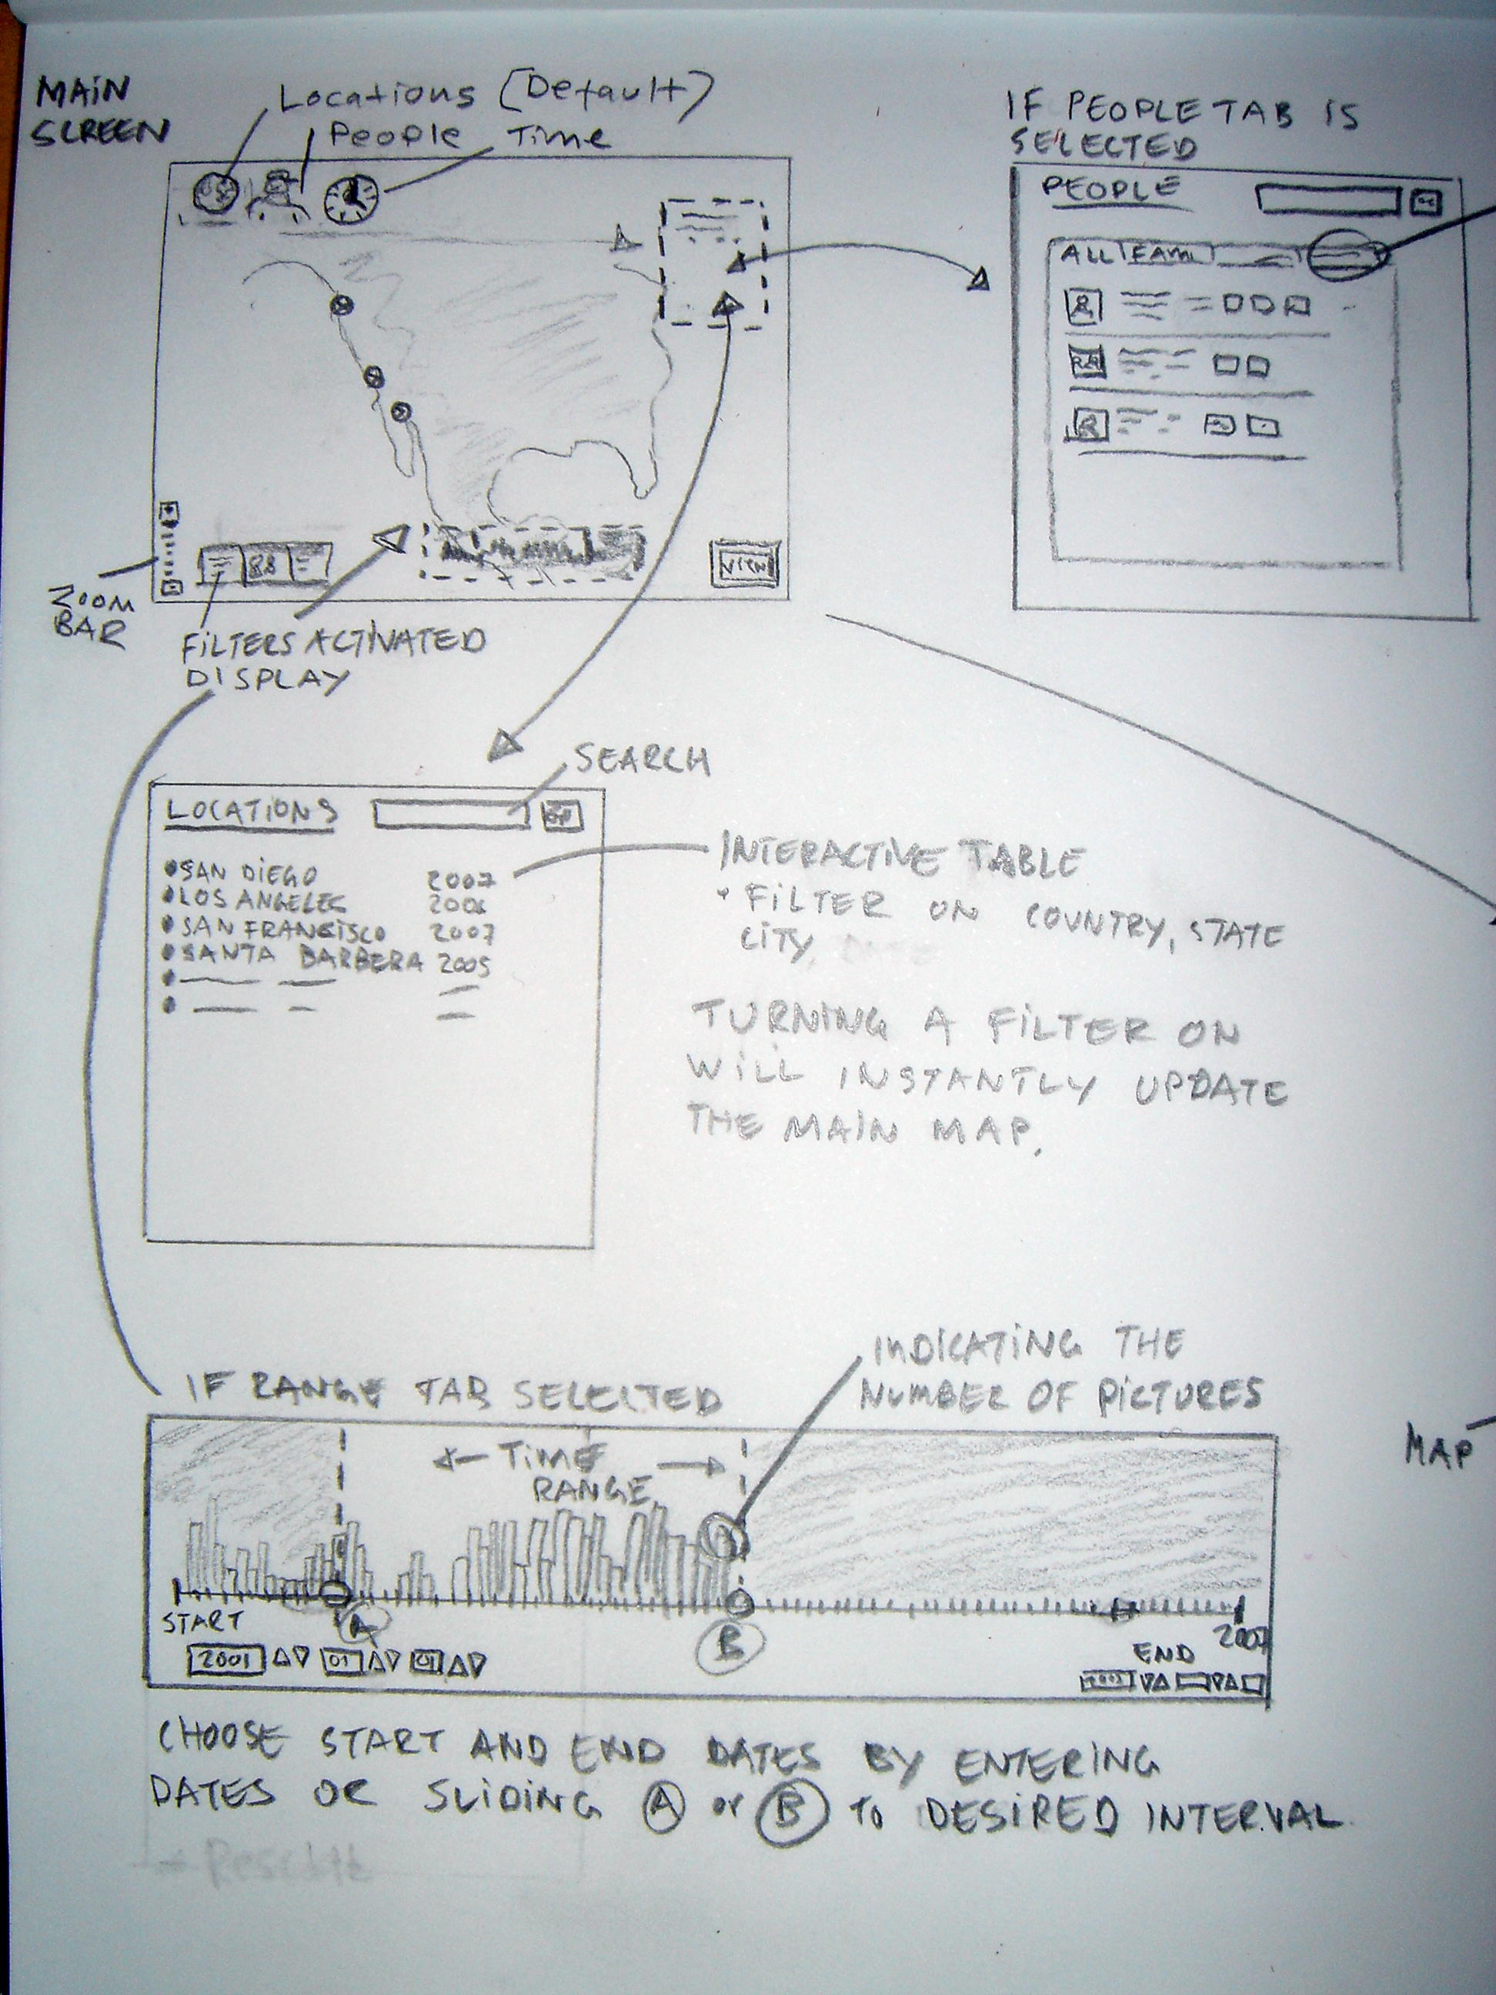
Filters
One important aspect of our interface is our filtering system. We used three different types of filters to make searching for pictures fast and easy. These filters consist of a place, time, and people filter. These filters can be used together and toggled on and off to get a refined search. The default setting on the interface is with no filter on.

People Filter
This is a unique filter that lets you search for a certain person or a group of people in a picture. When this filter is selected a transparent popup window appears. This window contains a search bar as well as four different tabbed windows. The four tabs are all, friends, family and public.

By selecting one of these tabs the search is refined to the group of people selected. By clicking on a person in the dropdown tab menu a selection is further filtered to that specific person (figure 2). Selecting a filter updates the map and the pictures in the view picture area (which will be discussed later). This section also lets you set access rights to your pictures. People in your friends and family tabs (inner circle) will have access to your pictures in these two sections. Also, a person in your outer circle can ask for and grant permission to a picture if it resides in the public section.
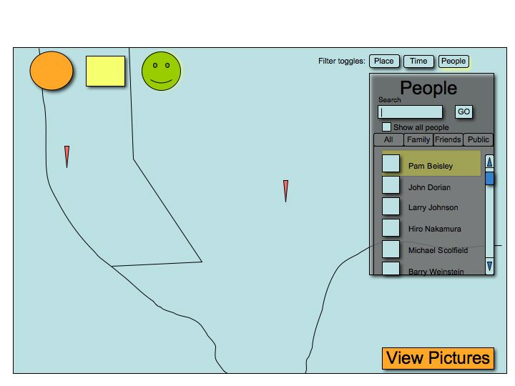
Figure 2. Computer based mockup displaying the people filter, the map updates instantly when the filters are turned on displaying fewer markers as the range of data decreases.
Place Filter:
This filter is a little simpler than the people filter. When the place filter is selected a transparent popup window appears again. This lets you enter data. This data can consist of a country, state, city, address, zip code, GPS coordinates, or a combination of these. Also, these can be selected from a list of places you have taken pictures in the past. Making selections here will update the map, update the picture view area and change the maps zoom accordingly.
Time Filter:
When the time filter is selected a timeline pops up at the bottom of the screen. This timeline is overlaid with a ware that shows how many pictures were taken at that time. This is represented in vertical lines over the time line, the more pictures taken at a specific time, the taller the vertical line. There are also two knobs on the timeline. One to set the most distant picture you want to view and one to set the most present picture you want to view. Adjusting these knobs update the map and the picture viewer to these time constraints. Also, a user can manually enter a start and end date to view (figure 3). This method will also update the map and viewing area.

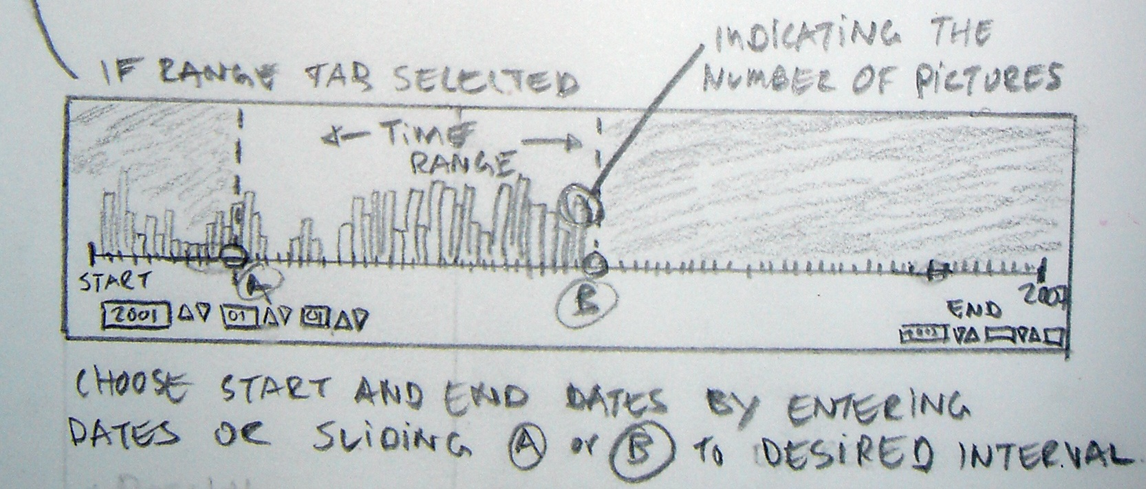
(Figure 3: a sketch of the time filter)

By adjusting and toggling on and off these different filters a user has a great amount of control of what he or she wants to view.
To access information once these filters are set to the desired settings, one would click on the markers or the view pictures tab and this would bring up the picture viewer that displays photos and thumbnails with slideshow capabilities etc (figure 4). To further enrich the interface all the markers on the map would be color coded depending on what category, such as family, friends etc. the people in the pictures belong to. This data would be provided by the cell phone that houses a Bluetooth enabled "Buddy List" application as described earlier. The groups could further be used to share the pictures with the people in them, no need for everyone to bring their own camera to the party and take ten identical images anymore. Or even more often, one camera, twenty people and a weak promise to email the photos the next day.

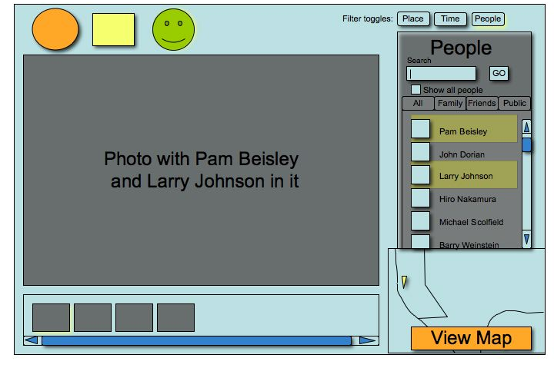
(Figure 4: Picture viewing area, currently containing all photos with both Pam and Larry)
Computer based mockup version

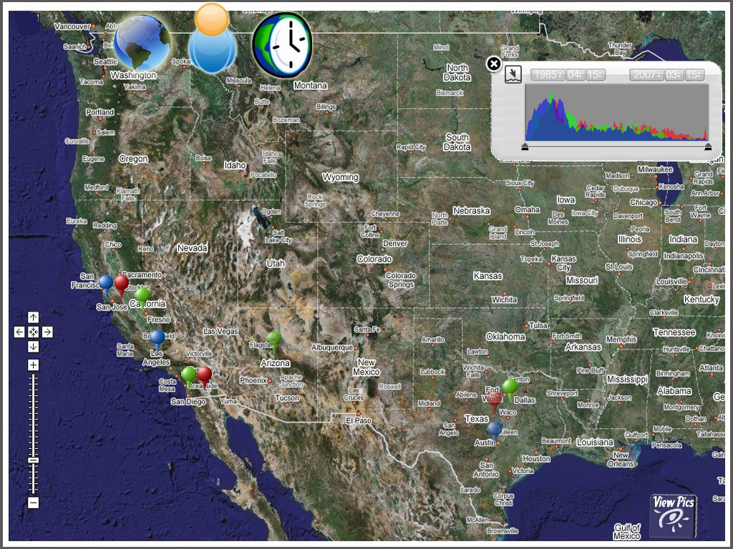

Computer based mockup version showing the time filter providing a “histogram” that will add or remove markers on the map depending on the selected date range.

Application technical platform
The suggested interface is clearly influenced by the current Web2.0 trend with Google Maps, Flicker and other modern web application. The interface is based upon common web techniques such as CSS, JavaScript and XML, often referred to as AJAX (Asynchronous JavaScript and XML). This web development technique enables creation of dynamic, interactive web applications that delivers a user experience that is closer to regular desktop applications than to traditional static HTML pages. By utilizing development frameworks and application programming interface (API) it is possible to create advanced applications within a short timeframe. To position documents in relation to the world/map we would use a JSP Tag library as a front end for Google Maps API this allows us to easily create maps, place markers on specific locations, zoom in and out, open overlaying tabbed info windows etc. The GoogleMaps API also enables GeoCoding which allows searching for locations based upon addresses and zip codes. Storing an address or GPS coordinates in a database and displaying it on a map suddenly becomes a trivial task. In addition to these fundamental techniques we have identified several possible open source projects that provide almost all the core technologies needed. To read GPS location we found a NMEA-0183 GPS protocol reader developed by the Embedded Interactions group at the Ludwig-Maximilians University in Munich, Germany. This piece of Java software for mobile devices (J2ME) comes with examples on how to access a GPS receiver via Bluetooth and read location data. Whenever a photo is taken a small application running on the “camera”, will read the GPS location and store it as additional information in the hidden meta-data fields (EXIF/IPTC) of each image file. When the image is uploaded to the server the information is extracted and incorporated into the database. The location and date is then used to group images into sessions/rolls or defining specific locations (1mi radius of X.XXX/X.XXX is UCSD)
Conclusion:
Our proposed interface deals with the interaction techniques of taking, accessing, uploading and tagging photos. The previous problems with these tasks were they all required a significant amount of time from the user to organize the data. As mentioned, out interface will remove the tedious process required to tag and comment taken photos. A Context Enriched Digital Photo will be taken and all of the desired information will automatically be tagged with it and uploaded onto a server. The program we envisioned will enable a user friendly cognitively simple way to view, edit and search through these photos. This system will not only help people store and search for pictures in a unique, easy and fast manner but also organize events, social interactions and time periods of ones life. Further on this concept may be extended to not only handle photos but a wide range of media and documents. Instead of organizing the information with focus of time as in the TimeScale article we see a beneficial aspect of incorporating the “where” type of information. We cannot ignore the strong contemporary trend of globalization, increased mobility and awesome computational powers in tiny devices all hooked up to a blazing fast wireless network with virtually endless storage capabilities. The hardware technology usually comes first, now its time for the applications and interfaces (aka. the hardest part)

