Applying Contextual Design
San Diego Oceans Foundation

7810273974 Martin Thall
Cognitive Science: 102C Cognitive Engineering
University of California, San Diego

Introduction 2
Background 2
Project team 3
Methodology 3
Contextual Design 3
Results from applying Contextual Design 4
Prototyping 7
Discussion 11

Introduction

Background
The San Diego Oceans Foundation (SDOF) was formed after President Reagan declared 1984 to be the ”Year of the Ocean” encouraging Americans to become involved in ocean conservation. The coastal waters surrounding San Diego is considered to be one of the regions most valuable resource, thus the city was declared as the ”point city”. One of their most important objective is to recruit and train community members to work on their various programs, many of which are aimed to raise public awareness since ”education is the key to conservation.”

The organization is part of the REEF monitoring program designed to collect data of the marine ecosystems around the world. Volunteer divers around the globe collect data that populates a central database currently housing more than 100,000 entries, a major source of information available to the the scientific community as well as the general public. To support this program the organization educates volunteer divers in identification techniques and have deployed a series of certification levels to ensure quality aspects of the collected data.

Project team
The broad spectrum of both academic directions and national heritage of our team deserves to be noted. The team consists of five members from the U.S., Sweden, Taiwan and China enrolled as undergraduate students at University of California, San Diego (UCSD) The major academic directions is equally diverse, from Cognitive Science to Computer Science/Software design and contemporary Interactive medias (ICAM) Similarly the previous knowledge and experience both within the target domain and in general varieties widely. Myself, I bring experience on analysis and design of computer software with a focus on distributed computing, i.e. Internet based applications. In addition, I hold a PADI Advance Open Water diving certificate and experience from diving in Sweden, Thailand, Malaysia and Australia. The diversity of the team is both an advantage and a disadvantage. The variance creates a multidisciplinary team that brings fresh ideas to the table but it also requires an effort to reach a mutual understanding of the project process and the target domain. Taken the individual differences aside the team has at least one thing in common, it feels right to assist an non-profit organization and we all appreciate or even love the ocean.

Methodology

Contextual Design
The method for reaching a rich and shared understanding of the target organization and its environment is central to the Contextual Design methodology developed by Hugh Beyer and Karen Holtzblatt. They are the co-founders of InContext Enterprises Inc. and authors of “Contextual Design: A Customer-Centred Approach to Systems Design” (2003?) The methodology is based on their decade long experience providing analysis and solutions to a vast variety of organizations. The methodology has a wide focus and covers both aspects of collecting data from the field and provides the team with a set of best practices on how to conduct the process and ensuring that the gathered data drives the design. This is crucial in a successful project, real world users provides knowledge about real world problems and reaching a rich understanding of this is the best way create innovative solutions. This approach is different from the traditional software analysis and design where a set of requirements is passed to a team of developers who implement them and return the results as-is with issues to be solved in the next revision. Much of the Contextual Design ideas on data collection have similarities with other methodologies, for example the User Centred Analysis and Design (Madsen, 1990) Their common nominator is the idea of reaching a higher level of software quality by placing the developer out in the field, among the intended users. This leads to a rich and more reliable understanding of the clients, the work they perform and what’s important to them. If a third party gathers the data and presents requirements there is a good chance of misinterpretation on what really matters.

The InContext: Contextual design method is a modern and rational approach that utilizes the total knowledge asset of the team. It relies on human observation, in-depth observation and interviewing techniques such as the master – apprentice relationship, co-design, think aloud, talk as you go and other more or less guided objectives.

The process is divided into several steps as listed in the table below. It’s mainly focused on larger projects and does best with adequate resources. The initial effort to gather data is time consuming compared to more agile, developer-centred methods. Ideally is a multidisciplinary team that possesses specific strengths in aspects such as behaviour and cognition, engineering, marketing, software development etc. It contains structures for assigning roles during interviews with guidelines to focus and guide the process. By working in the field and investigating the target the team will be equipped with knowledge to drive the design process further.

Notes on method
Not all of the steps applied to our design process. The scope of the project was initially broad and naturally constraints in interview scheduling, transportation, language and cultural differences had effects on the project. The work in a volunteer based organization differs widely from traditional corporation based businesses. To counter this the meetings were scheduled weekly and tried to meet with as many involved as possibly. We also had the opportunity to attend one of the training session organized by the SDOF. The organization provided us with artefacts and material that became a natural base in the discussions. No one really knew when but suddenly we all were using new terminology in means of communication. By moving closer to the target domain and getting to know the inner workings of it the data we gathered lead to ideas on further development.

Results from applying Contextual Design

After our individual studies of the method the team was formed and I initiated the contact with SDOF Outreach/PR Director Courtney Gosch. She proposed a list of ideas that would be suitable in scope for this project. Much of the first meeting was an introduction to the organization, what they do and how they organize activities. They provided artefacts, such as data entry forms, training material, brochures and references to literature essential to the area and much of the following week was dedicated equipping the team with an understanding of the domain. We acquired additional information and resources from the Internet and literature related from marine biology and fish identification and classification. The initial meeting generated a few models, some clarification but even more questions. About the various processes, how they are managed, structured and supported.

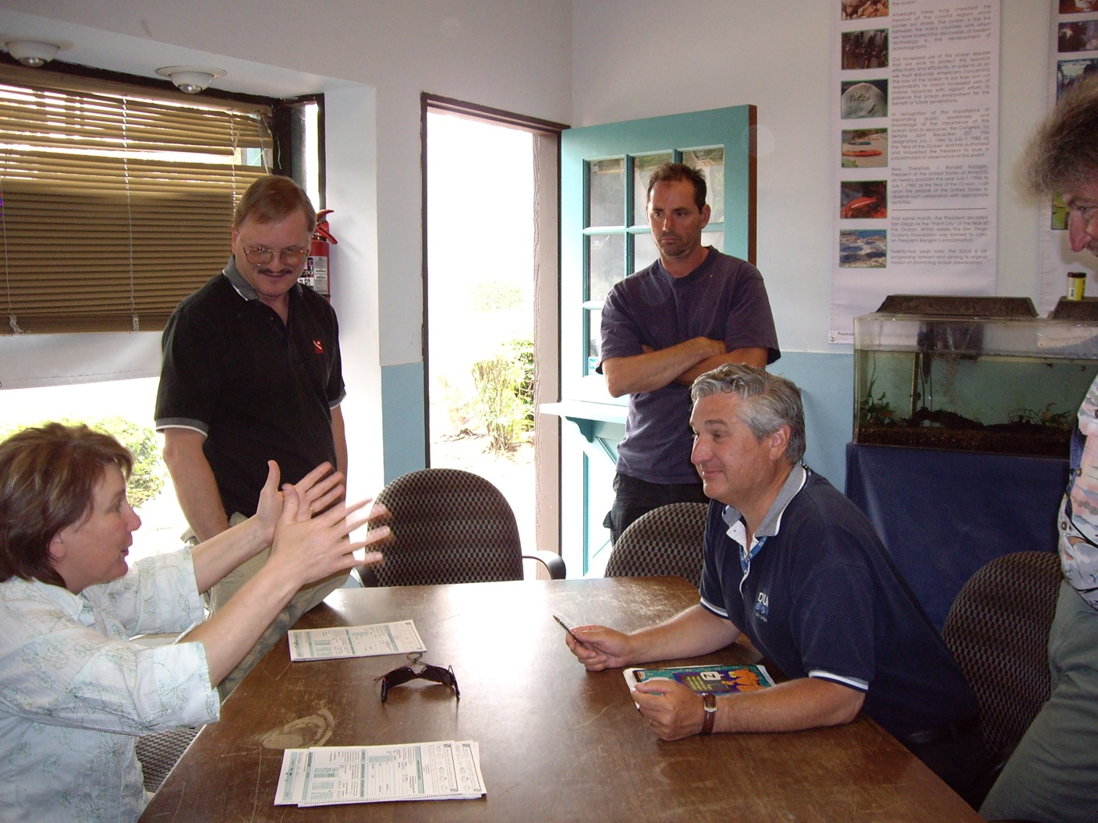 | Questions that came up during our team meetings were noted and brought up during our second interview that again took place at the SDOF HQ. This time we invited a range of individuals within the organization. This provided a great deal of data but also a great deal of work when trying to establish an coherent picture of the organization. They are in general very experienced and could be considered to be expertise in the field and assist in the education of volunteers. This gave the project a clear focus on the educational aspects of the organization.

The data collected from the first and second interview lead to the creation of models of the context the management and trainers of the organization exits in. Individual notes were consolidated in team meetings to a digital version using the OmniGraffle software. Larger size models can be found in the appendices. To establish a agreement we worked together in identifying statements that defines and encapsulates the cultural aspects in the model below.

The consolidated flow model was created after meeting several involved individuals and discussions within the team. The chosen scope and focus is mainly concerned with the REEF project related activities.

Since the actual data collection takes place under water it would require the team to posses equipment and necessary training to observe. From there we analyzed the processes further in our data collection process model.

After the volunteer is trained in fish species identification and associated tests he collects data on observations during dives in the San Diego area. The information is recorded onto a plastic slate while diving and then transformed into a scantron form that he/she sends in to the organization office. The information is validated and further processed before it’s sent onwards to the REEF head quarters that govern the specification. The San Diego Oceans Foundation as a satellite organization organizes training at various levels to promote knowledge that increases the quality of the collected data. This includes education on forms, diving routines, identification techniques and certification.

Note: The forms and logistics surrounding the scantrons and associated logistics could be a suitable project if working with the REEF organization. A web based submission service could ease the labour and resource intensive process.

The focus of the project was further crystallized on the educational aspects for the REEF project. The sequence model depicting the training and certification process presented a lack of study tools that could be useful to estimate the progress for the volunteers as well as aiding the studies. We had the opportunity to attend a training session and the following meeting concerned ideas on knowledge assessment. All this data and analysis started of our prototyping. The team found this a natural and area that stimulated our individual interests in cognition, media and technology.

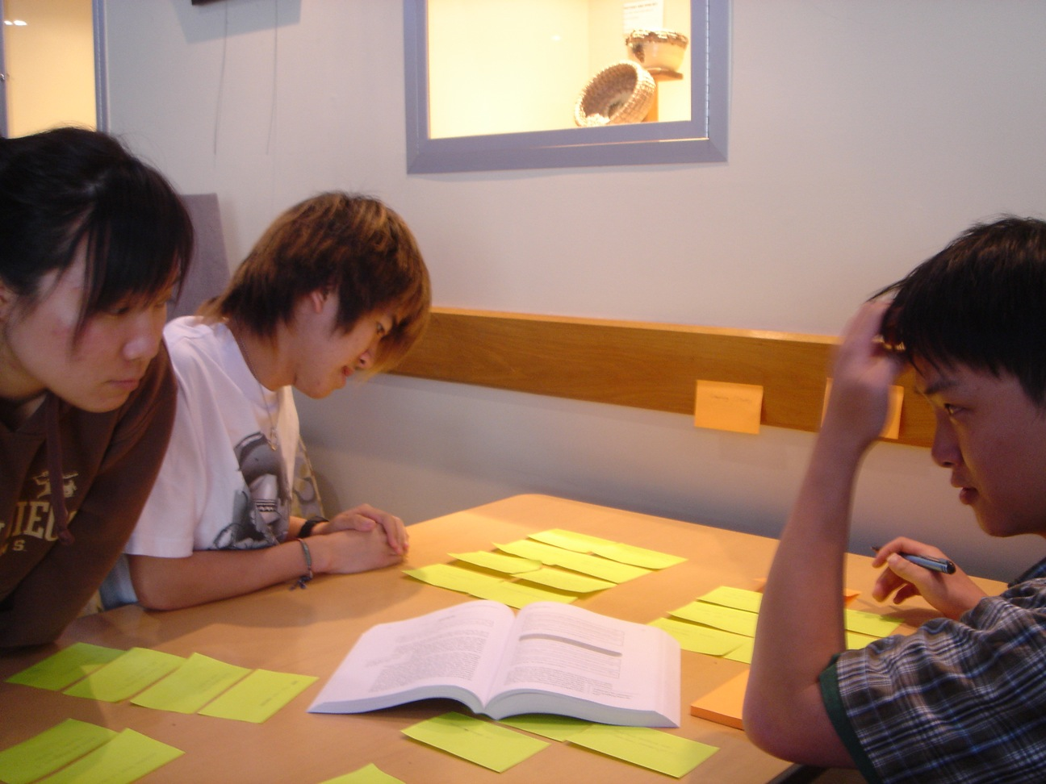 | In addition to the consolidated models we spent an afternoon attempting turn the data into an affinity diagram. This proved to be a rather difficult task that didn’t provide much use full new information.  In my opinion its excellent for communicating the findings between team members and the outside world but since we all participated on most of the interviews it became more of an exercise in agreeing on topics and categorization.

Prototyping
Based on the interviews, observation and gathered artefacts we identified two areas that could improve both the outreach to the public and provide assistance in the training of volunteers. The two areas was a) a taxonomically structured web-based application that would act as a central repository for information on marine species in the San Diego area. The second idea concerned a knowledge assessment tool that could be used as a resource in the training process. To revamp the study process the existing power point slides with images of fish species would be replaced with an interactive quiz type of application. This would provide the volunteers with a study tool they could access over the Internet for optional location. In addition it’s a tool that could be tailored to the various certification levels and customize to the five levels ranging from novice to expert. We developed a set of prototypes that were further refined based on received feedback in the iterative process.

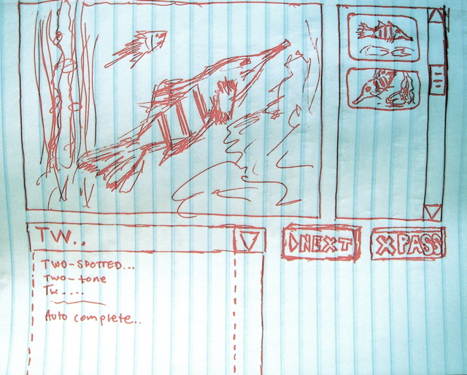

The second prototype refines the functionality and interface further. The alternative pictures below the main image were removed to be replaced by a randomizing selection from an image repository. Learning would then be more based on the actual features of the fish and not the on the specific photo. The left part of the prototype illustrates different options to select or enter the corresponding family and species. The bottom left option with a top select list that would dynamically update the field below with members got most positive feedback.

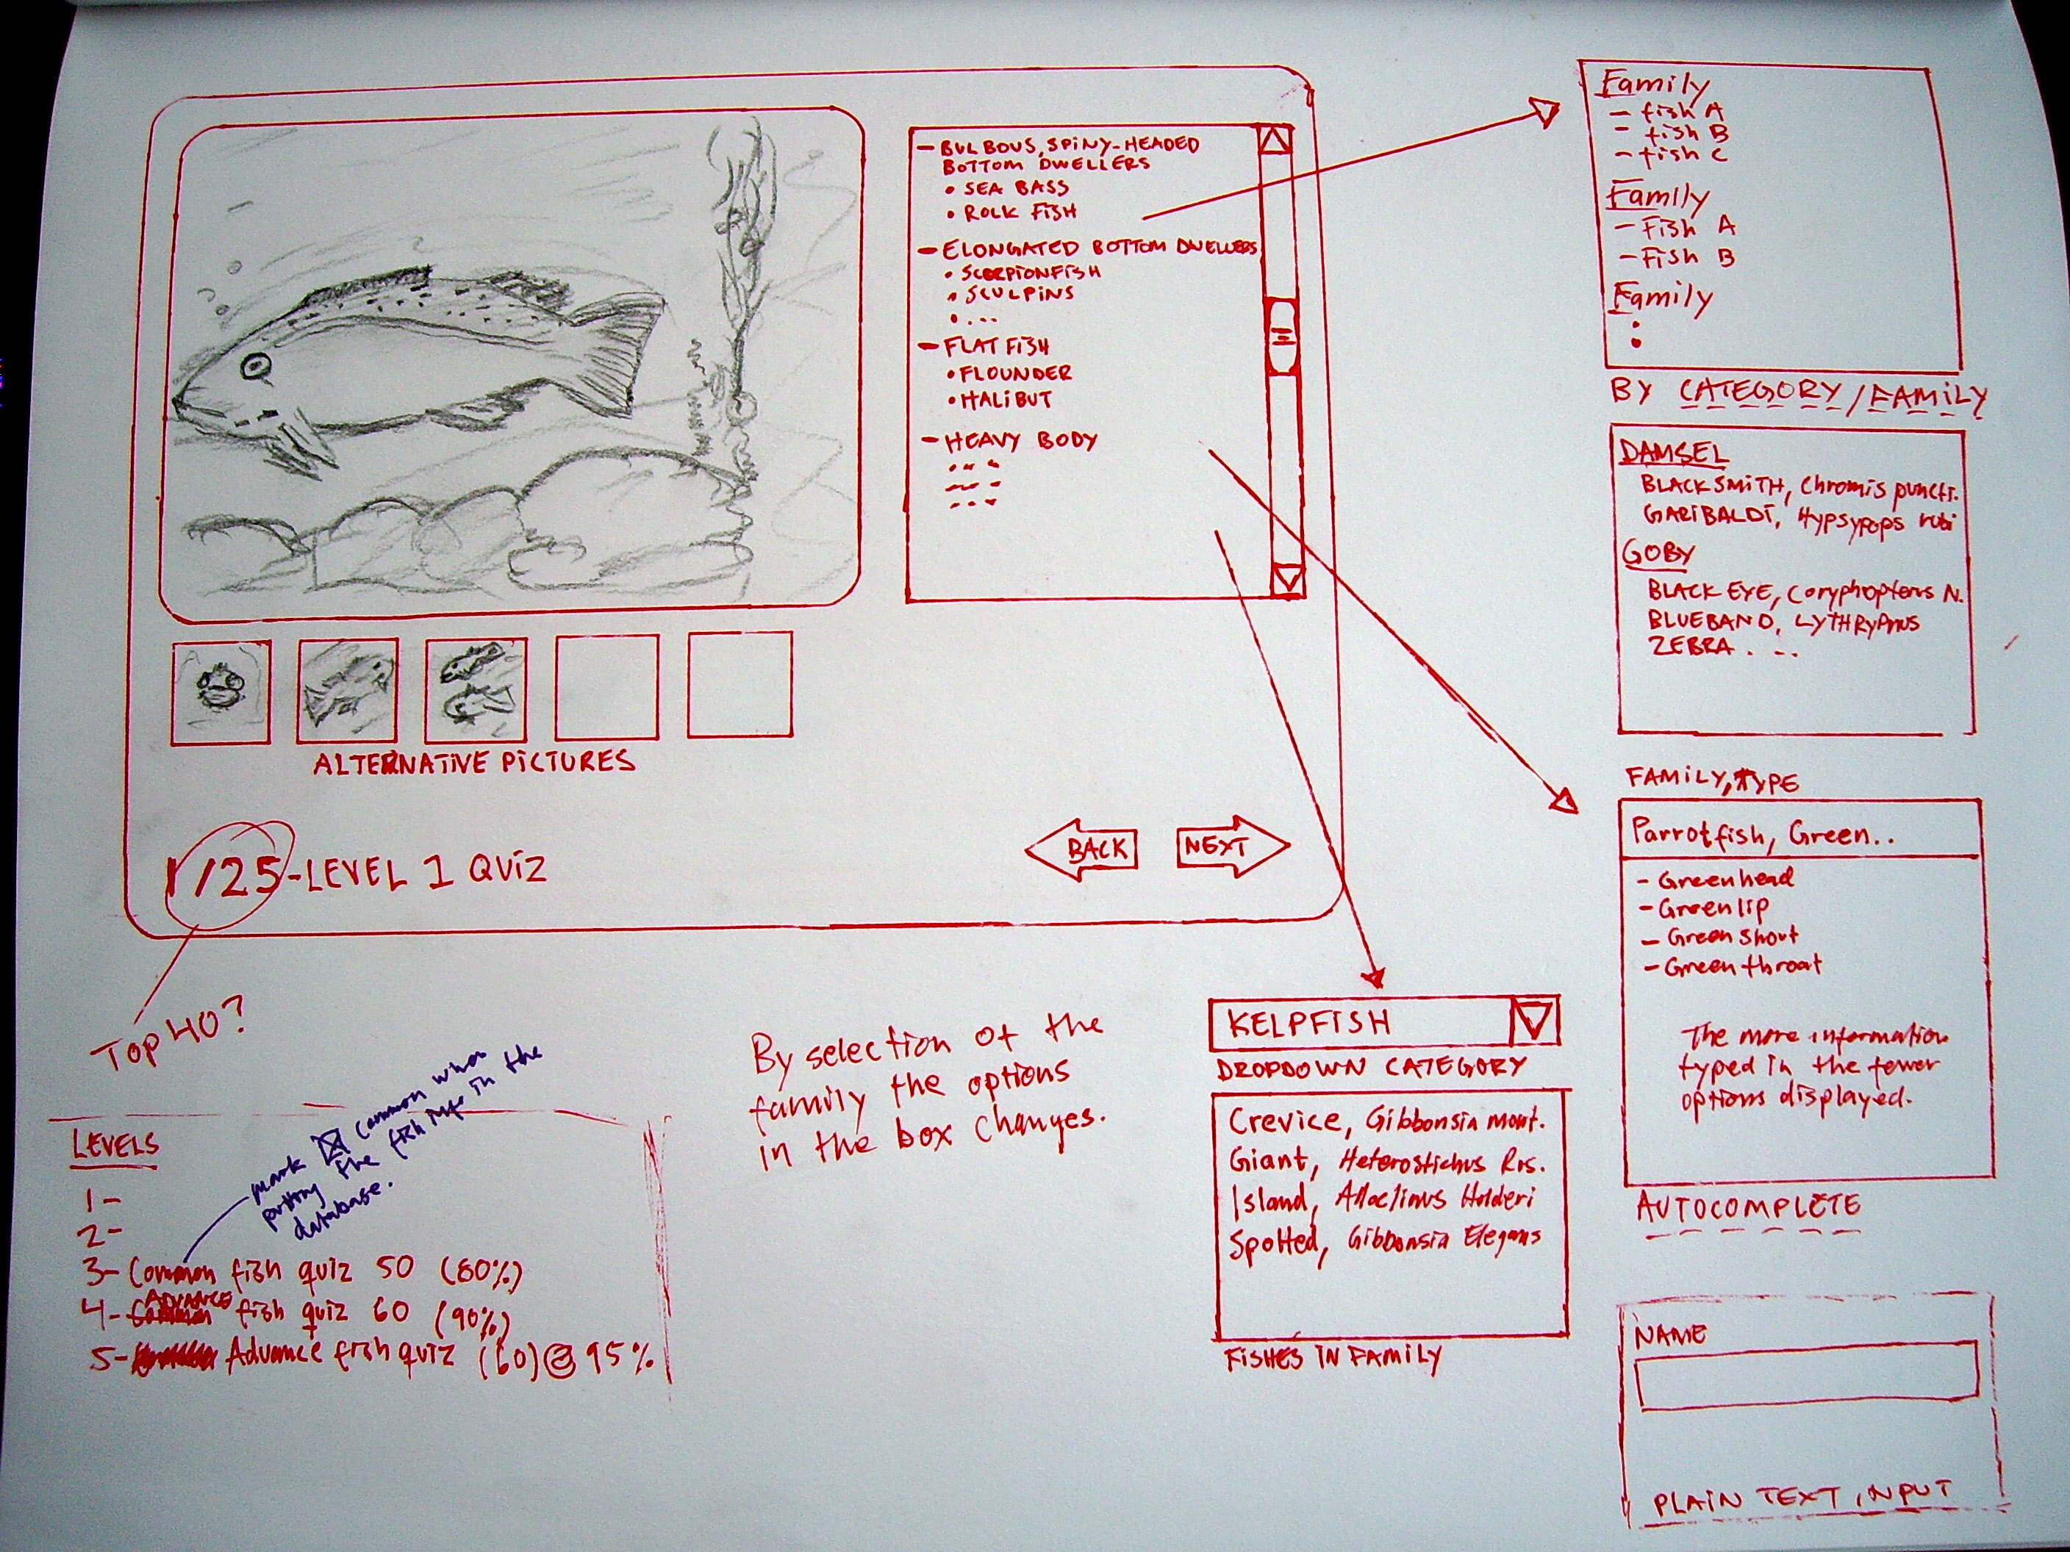

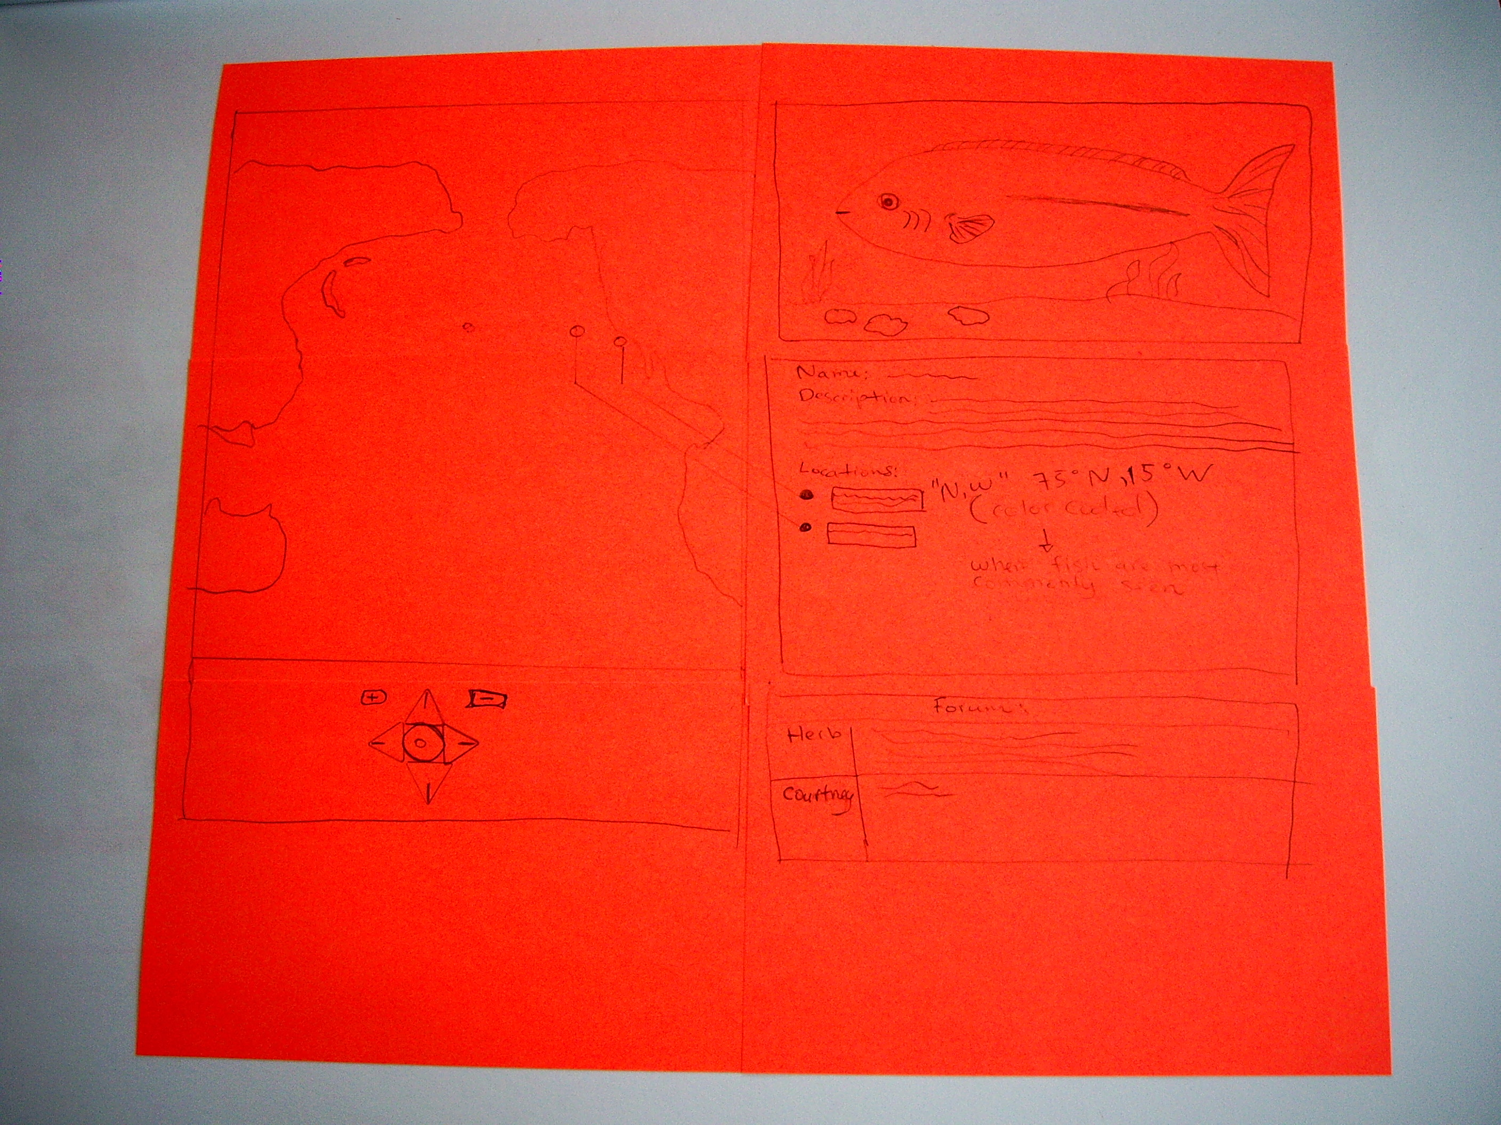 | In addition to sketching we tried a mock-up design of Post-It component as a parallel thread to the knowledge assessment / quiz tool. Most valuable is its setup that invites co-design in the simple but flexible manner. This prototype displays the ideas we had on a Wiki-type of database for San Diego specific marine organisms. This focus was on providing the public with information of the state of the surrounding coastal waters and thereby raise public awareness.

To try a different approach the second iteration contained this alternative prototype. The volunteer would based choose the fish that corresponds with the displayed name. Although the “photo-to-species” approach was determined to be more suitable learning, thus enhancing the quality of the data collection process. | 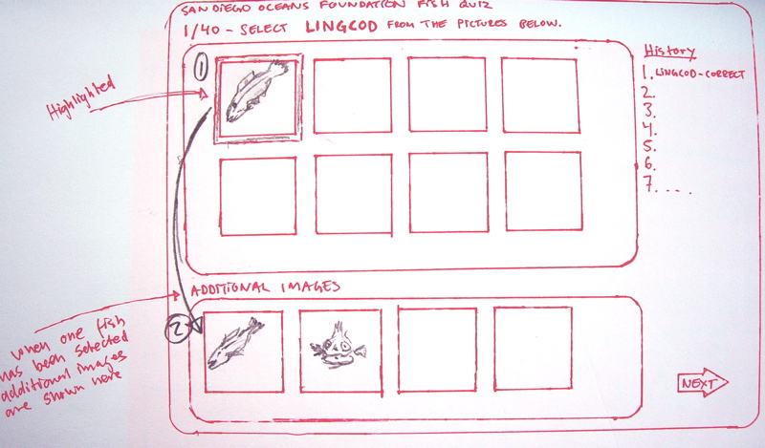

The ideas on creating a San Diego specific knowledge base were further investigated as a parallel process to the knowledge assessment tool. The recent launch of their website demonstrates the overall strategy of the organization to adopt new technology and actively working on reaching out to the community. Since the organization was in the process of revamping their website we tried to have this in mind when designing the prototypes. We gained access to the new website before it was launched and attempted to used this new graphical profile as a guideline.

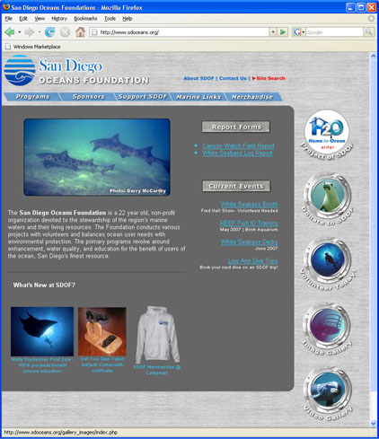
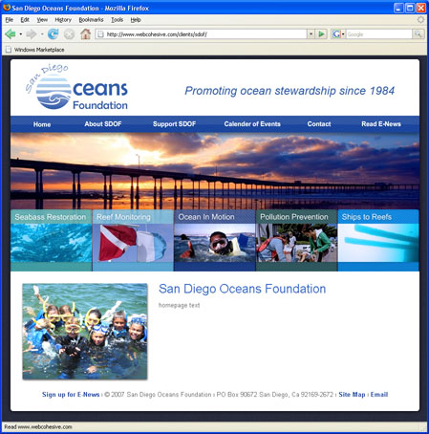
Current website New website

The discussions led to a prototype that we used to focus what type of information it would contain and what sort of functionality that could be useful for a wide range of users. Ideas on community contribution from the members and management aspects were discussed and brainstorming on functionality spontaneously occurred.  The taxonomically organized database would have several methods for searching and accessing information. We spent a fair amount of time discussing a feature based search engine where choosing fins, sizes and other attributes would filter and locate species for easy identification. Unfortunately we had no opportunity to refine and further develop a prototype for this since we chose to move the knowledge assessment tool further to a digital version. | 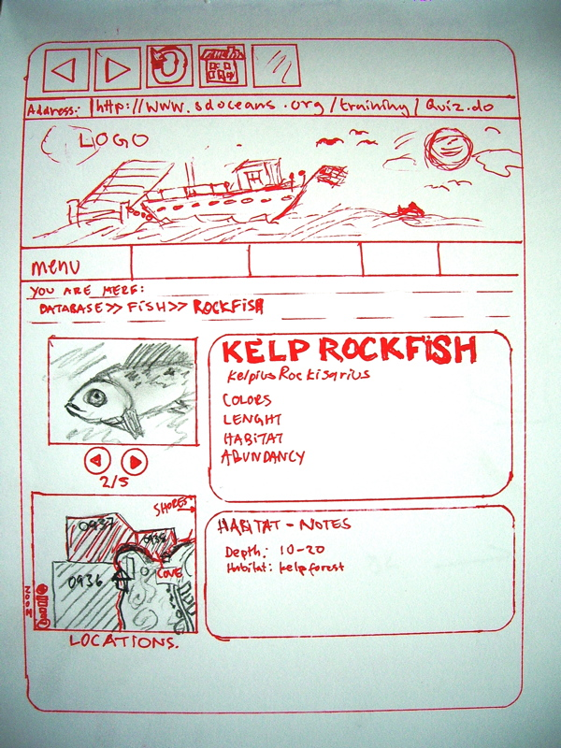

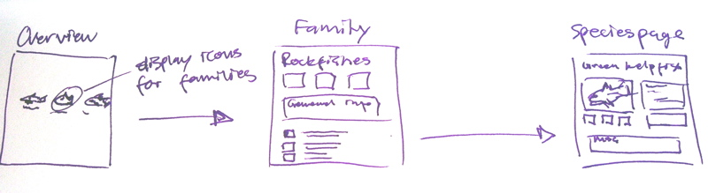
Page flow for the taxonomical search

The first alternative for the digital prototype demonstrates a solution using standard Internet techniques such as HTML/Javascript and CSS. It does not need any installation of third party software/plugins. The dropdown select list is dynamically linked and updates the list of species based on selected family.

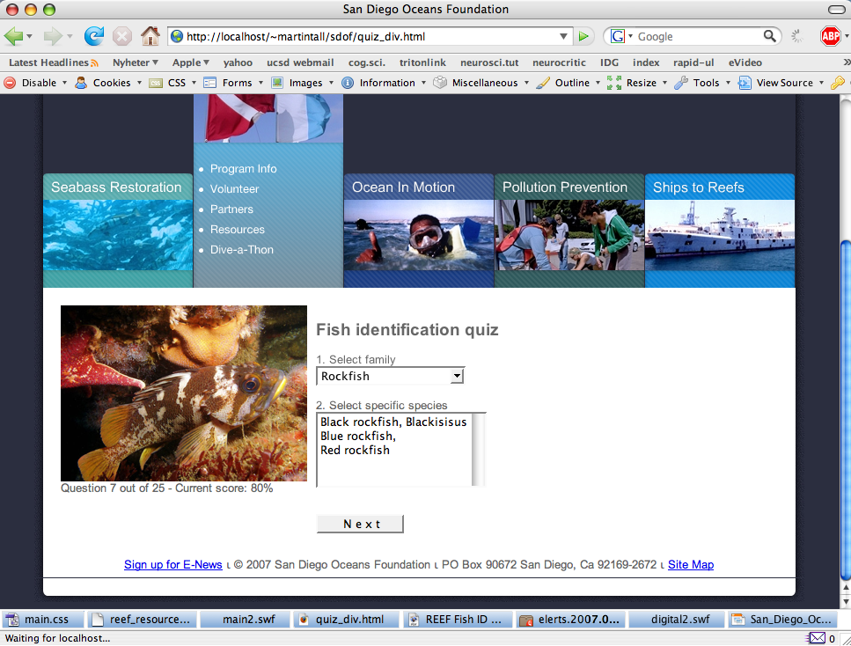
Alternative 2 for the digital prototype illustrates a richer interface but requires a plug in from Adobe to display the Flash program. This solution is feasible since much of the SDOF newly launched website is build on the platform.

Discussion

At this stage of the digital prototypes the way to short U.C quarter was coming to an end. We all wanted to do more but there was a sense of achievement and pride in what we had accomplished. Personally, I expected larger outcome but lack of knowledge, skill and motivation in the team took its toll. Some members of the group were mainly concerned with activities related to their individual grade, rather than going the extra mile and doing something innovative.

With the right competence and enough time the project is clearly feasible. Its not rocket science. An average web developer should be able to code the quiz part in one or two weeks and the fish database within 1-3 months depending on the final specifications and features.

However, at the end of the day the members of the team gained experience in many aspects other than applying the method; most prominently in interaction between global citizens, exploring cultural differences and ways of doing things. After all, it’s an educational project in a class without any requirements on actual implementation.

